Call for Participants
Ukrainian-German Work/Study Camp (35 participants)
Heritage preservation in L’viv – 13.08.2019 – 19.08.2019

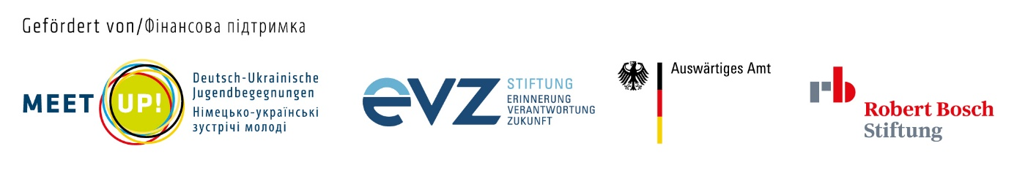
Are you interested in Jewish culture, history and heritage? Have you ever wondered how the life of an ethnical minority looks like in other countries? Do you want to learn more about Ukraine and its ethnicities, living side-by-side through centuries?
International Volunteer Camp “Heritage Preservation” is looking for participants, who would like to work for the preservation of Jewish heritage in Ukrainian city of L’viv. You will have opportunity to:
- learn more about Jewish history, culture, traditions, holidays etc.
- participate in the intercultural dialogue between German and Ukrainian participants
- meet local activists, authorities and decision makers involved into ethnical policies and heritage reservation
- participate in educational seminars and expeditions, connected to the topic
- take part in creation of materials for local and regional media (articles, blogs etc.) and a short film about this camp
- visit beautiful but yet undiscovered by mainstream tourists spots of Western Ukraine
Participants will be involved into manual work connected with cleaning and preservation of Jewish heritage sites. Each participant is also responsible for preparation of small guides about places we are going to attend through the program.

Financial conditions:
Participants have to pay a placement fee of 50€ to SCI and additional fee of 10 € to our Project Partner on arrival in Ukraine. Food, accommodation and local transportation during the camp program are covered by Project Partner. Travel costs in amount up to 110 € will be reimbursed for international travel costs after all original documents have been received.
Participants must have their own insurance coverage.
To apply for participation in this camp, please follow the link:
https://forms.gle/AWPe4593e3tVyb2M6
Applications for the camp can be done immediately. You will receive an answer within 5-7 days.
If you have any questions regarding this camp, please write to the following e-mail address:
outgoing@sci-d.de
Good luck, and looking forward to seeing you in L’viv!
--

Service Civil International - Deutscher Zweig e.V.
Blücherstr. 14
D-53115 Bonn
Tel: +49-228-21 20 86
Fax: +49-228-26 42 34

